### Report

**Difference between their working principles**

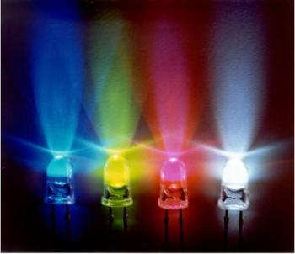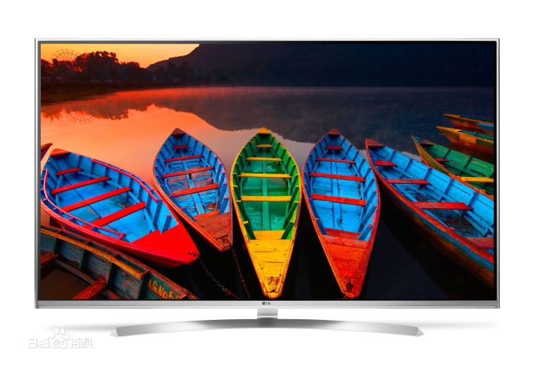

LED can emit visible light whose color depends on the band gap of the materials forming the p-n junction

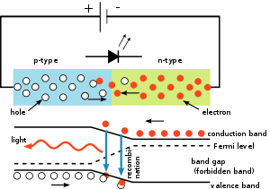LCD images by changing the orientation of liquid-crystal molecules to constitute different levels of gray. However, LCD can’t emit light by itself, so it need external light to product a visible image.

**An example of TV**

Both LED and LCD TVs are liquid crystal displays. The basic technology is the same in that both television types have two layers of polarized glass through which the liquid crystals both block and pass light. So really, LED TVs are a subset of LCD TVs.

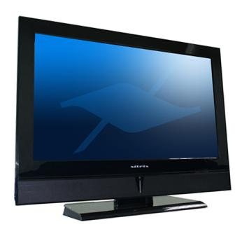LED differs from general LCD TVs in that LCDs use fluorescent lights while LEDs use those light emitting diodes. Also, the placement of the lights on an LED TV can differ. The fluorescent lights in an LCD TV are always behind the screen. On an LED TV, the light emitting diodes can be placed either behind the screen or around its edges.

**Respective advantages**

LED has a larger viewing angle, smaller size, longer lifetime and shock resistance. As a result, it is of high efficiency and is more energy-saving

LCD is cheaper because of its high technological maturity.

### Reference

LCD and LED displays in Wikipedia

[https://en.wikipedia.org/wiki/Lightemitting_diode#Considerations_for_use](https://en.wikipedia.org/wiki/Lightemitting_diode)

<https://en.wikipedia.org/wiki/Liquid-crystal_display>

TV example from howstuffworks.com

<http://electronics.howstuffworks.com/difference-between-lcd-and-led.htm>

Images

LED:

<http://p4.qhimg.com/t01db56d2c3c7424150.jpg>

LCD:

<http://wang1314.net/uploadfile/2015/2015-05-07/1430958825132u_396952_uw_800_wh_539_hl_40629_l.jpg>

Working principles: <https://upload.wikimedia.org/wikipedia/commons/thumb/d/d7/PnJunction-LED-E.svg/300px-PnJunction-LED-E.svg.png>

TV:

<http://www.xitrix.net/x2/images/lcd/TV-B.jpg>

Led watch:

<http://static.dudeiwantthat.com/img/style/watches/kisai-7-led-watch-3639.jpg>